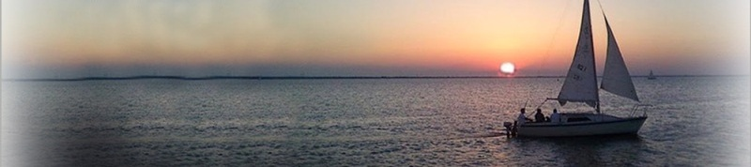
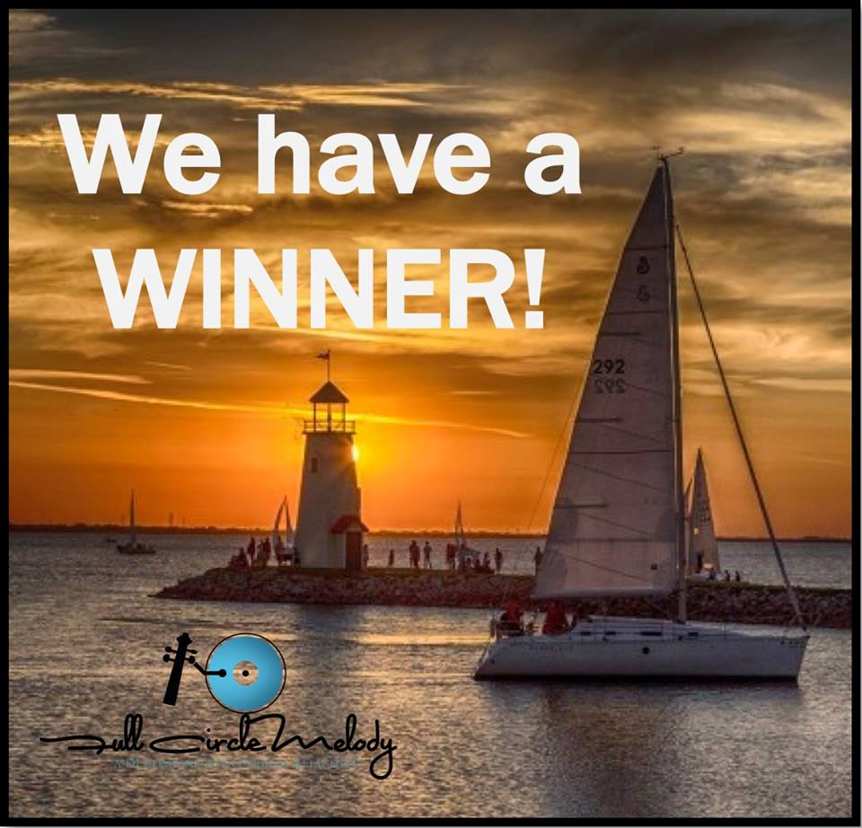

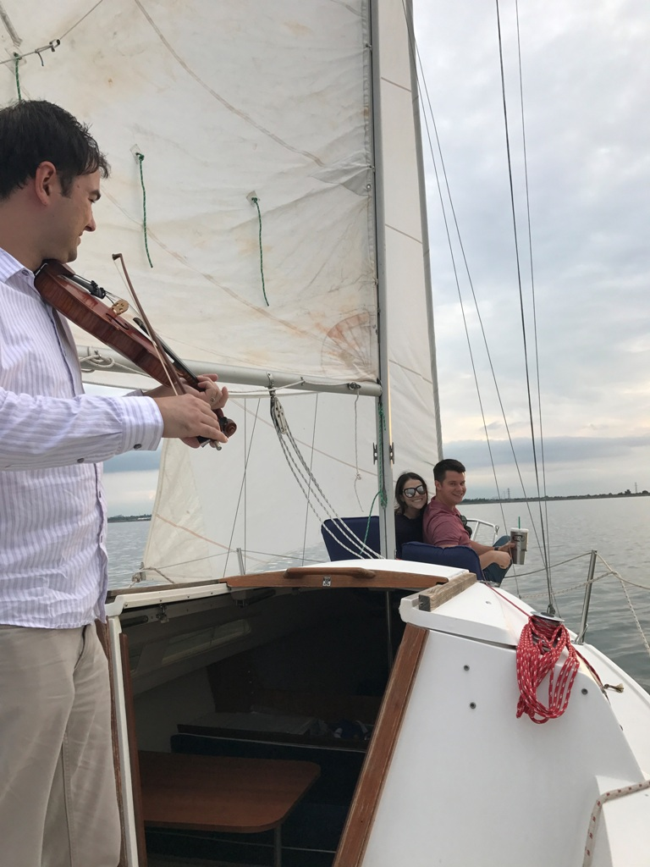

Enjoy a truly unique and romantic evening sail while being serenaded by Full Circle Melody. http://www.fullcirclemelody.com/

Call for details and reservations: Bill (405) 922-7787

S/V Nevorica
Chapter Seven (continued from the July newsletter)
Washington DC and beyond… the summer of 1991

Up until the time that Charlie joined me in Norfolk some time ago in 1991, I had been sailing alone much of the time. It was not that difficult to manage my heavy ketch rigged 41 Formosa on the protected waters of the Chesapeake, but having him aboard was a blessing. We have sailed together a few weeks dropping the hook in out of the way places up and down this huge and historic bay. In Washington DC we enjoyed the luxuries of the Washington Yacht Club, and the sights and sounds of our nations capital.
Charlie was still a little gimpy, but in this city of monuments and museums, he was determined to see everything. His limp was the result of a twisted ankle he received jumping from the boat to the dock in Portsmouth. It must have hurt like hell because over the course of two weeks the injury swelled, turned black, then blue, then red, then slowly got better. On October 6th Charlie turned 40 and we left DC only to run aground south of Quantico, Virginia. Oops!

October 20, 1991
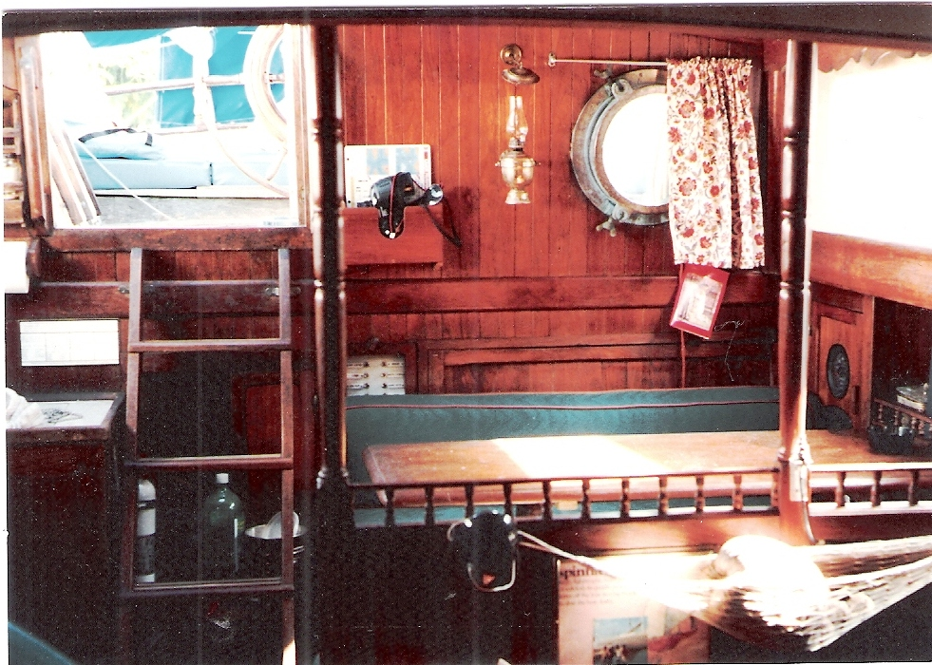
There are many reasons we go cruising, but they can all be summed up in one word: adventure. The thought of casting off that dock line with a fully provisioned boat and leaving out for exotic places is intoxicating. Exploring all the waters of the Chesapeake Bay would take a lifetime, but I didn’t come here to see it all. I was here to savor it and move on.
This was a long-range cruise, one that continues through several seasons, and would allow me to follow the fair weather, from north to south. Having spent almost two months in the Chesapeake Bay, I was more than ready to leave. Summer was gone and the days were getting noticeably shorter and cooler. I have read that wise skippers around here schedule the 1,090-mile voyage between Norfolk and Miami so that they neither catch up with the mosquitoes nor get caught by the snow. A workable schedule involves dropping Massachusetts astern by the first of July, and reaching the Chesapeake by the end of the month, spending the summer, and leaving just in time to enjoy the fall foliage. By the time October arrives, the Annapolis boat shows get into full swing. After that, it’s a good idea to leave Norfolk, and the wet, nasty weather, behind you.
Our home base in the Chesapeake area was the city docks at Portsmouth, VA. Situated across the Inter Coastal Waterway (ICW) it was a free place to park and other than the hourly ferry boat from Norfolk, we were pretty much the only other boat around. The only down side were the tourists. The city docks were part of a renovated waterfront park, and unlike a marina, it was open to the public. Our lovely dock was just next to the park and boardwalk. There were mornings when looking out a porthole you might be startled by a tourist looking back in. We had spent way too much time here, and now we were being mistaken for one of the park’s nautical attractions.
To head south, there were two options: go outside into the open Atlantic, or down the ICW. So at 10 AM we pulled the mooring lines aboard, and with our newly acquired dinghy and outboard securely lashed to the foredeck, we set out down the ICW canal, referred to locally as the “the ditch”.

We motored south on the canal passing under what seemed like an endless series of drawbridges and locks. The route took us through the heart of the city and the water was filthy. This was not the prettiest parts of Virginia. The banks were mostly commercial shipyards and small dirty marinas, but by late that day we entered the Outer Banks of North Carolina.
The land of beginnings, some call it. This is where England first attempted to colonize the Americas, (with disastrous results). The northern Outer Banks is characterized by a series of sand dunes that stretch from the sound to the sea, from Corolla south to Nags Head. Kill Devil Hill was one of the larger of the dunes, and was the site of the Wright Brothers first flight in December 1903, which placed Kill Devil Hills forever in the history books, and began the age of aviation.
Having left the commercialized canals of Virginia we were now surrounded by the breathtaking beauty of North Carolina. The low shoreline was thick with hibiscus and tall grasses inhabited by sea birds of all description. This long and narrow spit of sand separated us from a tumultuous Atlantic Ocean and allowed us to cruise south in great comfort.
We raised sails where conditions were right, and motored when they were not. We managed to cover thirty to forty miles a day dropping anchor near scenic spots like Albemarle Sound, Alligator River, and Belhaven Bay. The ICW is like an Interstate highway for boats. This time of the year the canal is full of sailboats large and small moving south for better climes. You may know these migratory folks as “snowbirds”.
And like travelers on a highway, you want to look early for the good places to stop for the night. About forty miles south of Belhaven we anchored on the Adams River near ICW mark number “9”. We discovered that these little off the river spots were great for meeting fellow sailors and it was here we invited George and Cathy to join us for dinner. Cathy brought curried chicken and Charlie made spaghetti. Like fellow seamen have done for ages, we talked and laughed about our adventures until late that evening. Like us, they also were headed for Florida aboard their 38 foot Irwin.
By the time we made Little River, South Carolina, a week has passed and we are truly veterans of the “ditch”. Now well versed in the enounces of our trek south, a day of moving down the canal is a routine of meals, taking turns at the wheel, and waiting for drawbridges to open. Today I wanted to stretch as many miles as I could before stopping and so I had passed one too many adequate spots to anchor. A few hours earlier a swing bridge had literally slammed shut in our face, delaying our progress. Now it was 6:30, getting dark, and the canal had narrowed to a long stretch of commercial fishing wharfs on one side and shallow marsh waters on the other. Desperate for anything to tie to, we pulled up along side the remains of an old wooden dock. The pilings were rotten, portions of the decking had fell away years ago, and large rusted bolts protruded from the sides. The sight of this ugly thing made me grimace as I imagined the damage it might do to the white fiberglass sides of my Nevorica.
Anchoring on a tidal river is not difficult. You just need good ground tackle and room to swing when the water direction changes. By now we’ve learned the water current changes about four times a day with the change of tide. So if you plan to spend a night at a dock you better tie her good from all directions. And so I did. Charlie had run off to do some reconnaissance of the dock owner, but when he got back he nearly fell off the dock with laughter. I had that boat tied in every imaginable direction, I used every piece of line I had on board, every fender, and somehow even involved the gin pole as a standoff just in case. Oh well, Charlie will tell you; I do love to tie knots.
Charlie had found the owner of the derelict dock in a bar nearby. He also owned the bar and it was fairly obvious that he was its best customer. His name was Royce, a real nice guy, and very drunk. He not only granted us permission to use his “marina”, but was nice enough to loan us his truck to run for groceries. The only warning was, “don’t mess with my gun or my golf clubs”. I’m pretty sure he was ex-navy. He ended every comment with “I’m not bullshittin ya!”
At 6:30 the next morning the rising tide lifted our keel from the muddy bottom. After a brief affirmation of affection from the land wenches, (phone call home) we were again on our way south.

(to be continued)

For the boat owners at Lake Hefner – “Boat Watch…”
This is a service we have done for years and is a great way to protect your boat investment. We will inspect your boat and send an email report once a week.
We will check: Mooring lines, Fenders,, Battery charger, Sail covers, Rigging, Outboard motor

For details and rates: http://www.sailorbrains.com/services.html

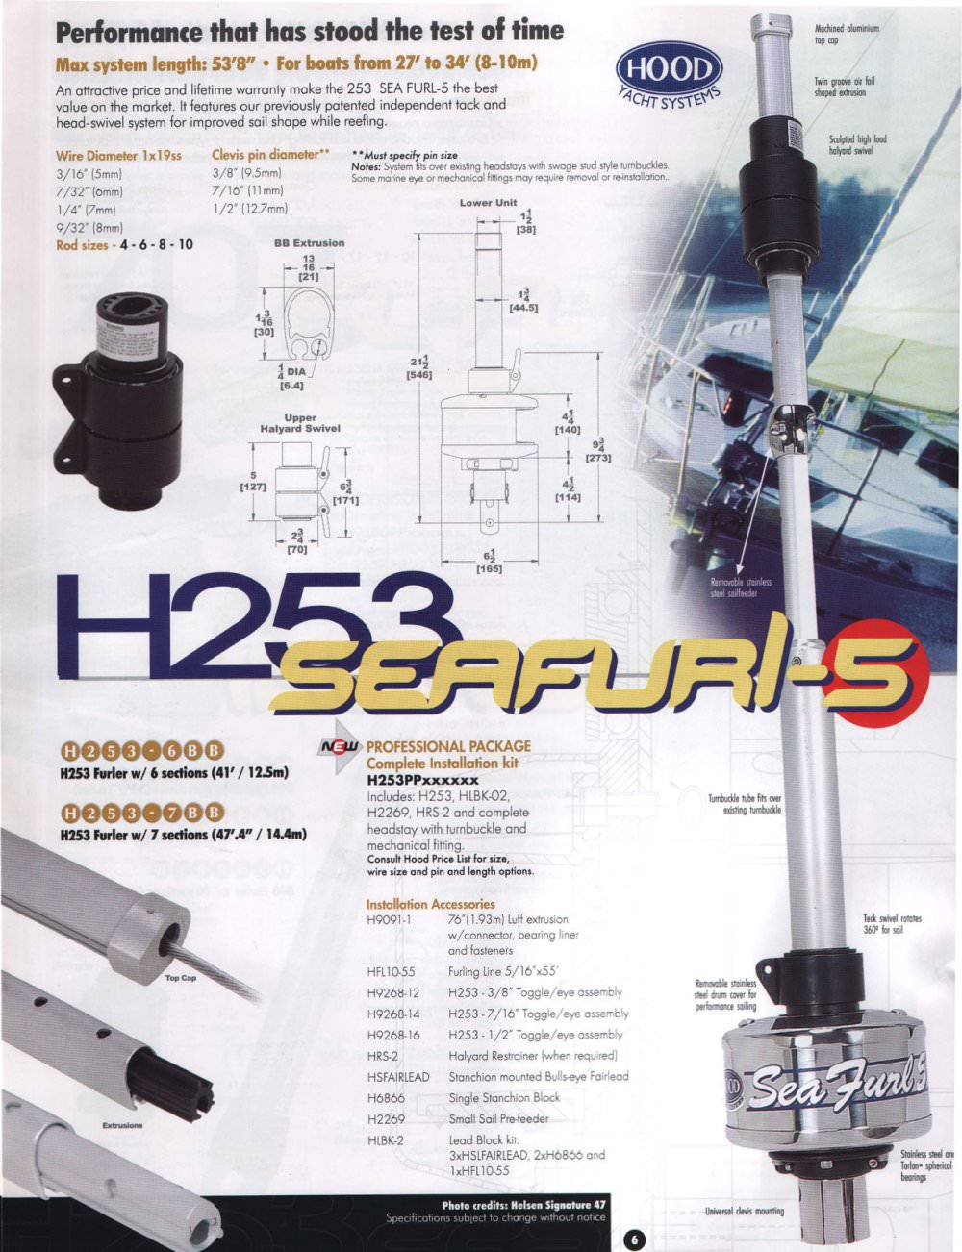
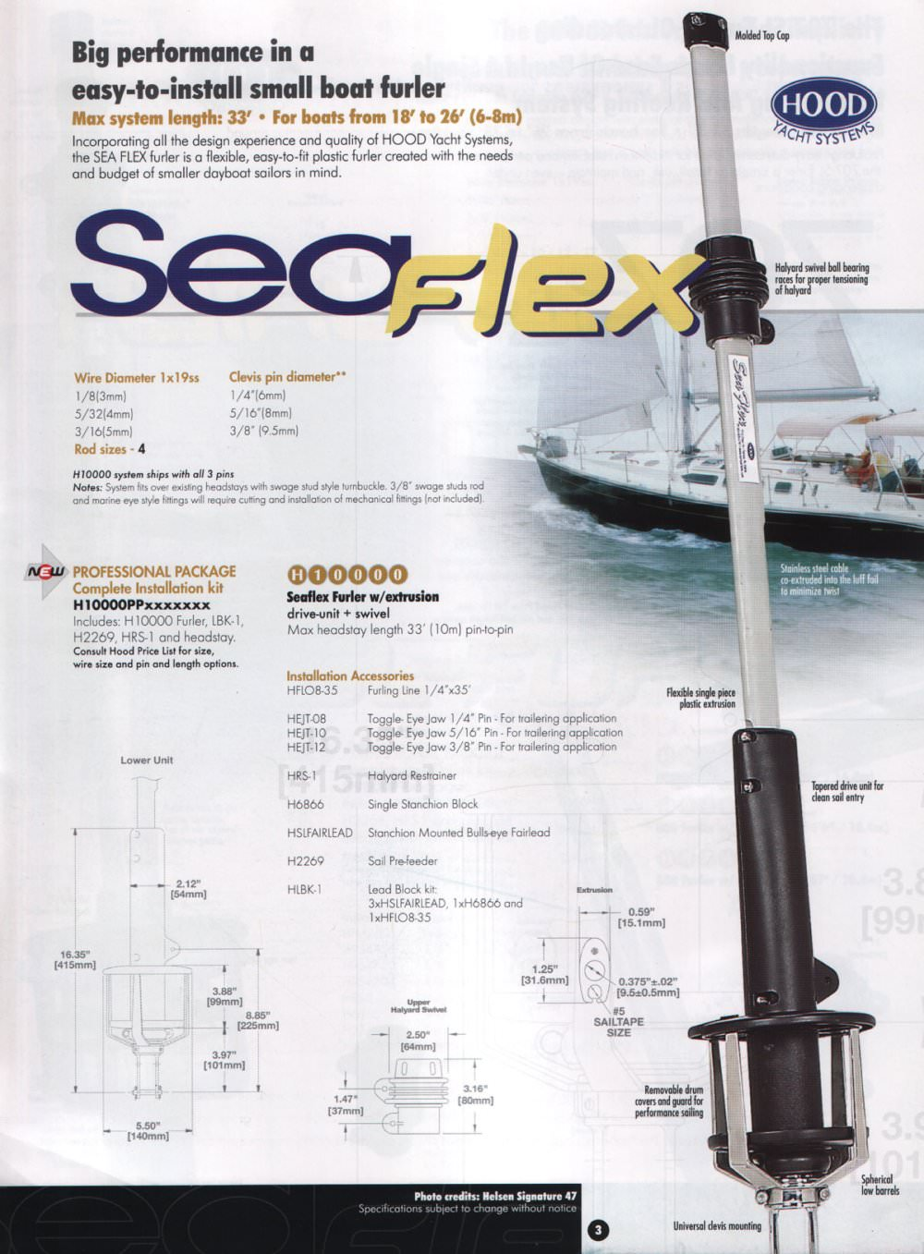
Jib furling systems…they make it so easy!
A must for the solo sailor! I am a dealer/installer for Hood Sea Flex and Sea Furl. Jib FurClers make sailing a lot easier for the solo sailor and much safer than having to run forward to raise and lower the jib sail. Pull the furling line and roll it up. It’s that easy!
SeaFlex for boats 18 to 26 feet
SeaFurl for boat 25 to 33 feet

Call for a quotation…

Boats for Sale
Year | Make/Model | Engine/OB | Sails | General Condition | Trailer | Asking
1983 | Catalina 25 | 9.9 Elect start Merc | Main & furling jib | Good | yes | $7,000
1975 | Chrysler 22 | 5 HP Nissan | main & jib | Fair | yes | $2,200
1971 | Irwin 23 | 9.9 Johnson | Main, 2 jibs | Good | yes | $2,700
1985 | Sovrign 23 | 9.9 Honda elect start | main, 2 jibs, spin | Very good | yes | $8,900
1974 | Ericson 27 | inboard gas A4 | main & jib | good | yes | $5,800
1995 | Mac Greggor 26S | 8 HP Nissan | 2 Main, 2 jibs | Very good | yes | $7,600
1978 | AMF Sunbird 16 | none | Main, jib | Very good | yes | $2,800
1992 | Catalina Capri 16 | none | Main, furl jib | Very good | yes | $4,000

Mark your calandars…The Sailboat Swap Meet is coming again!
All day, Saturday, September 2nd from 9 AM to 3 PM.
Place: 913 NW 79th near Western & Wilshire. Indoor and Outdoor space. Lots of tables will be available.
Items: Used Sailboats Boat trailers SS Parts & rigging Hardware
Lines & blocks New & Used Sails Outboard motors Teak wood parts
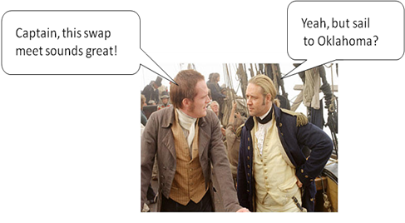
BUY & SELL… Bring boat stuff to sell, anything nautical, and come early.
This event will be advertised in the Oklahoman, Facebook, and
on multiple websites. This will be an excellent opportunity to
make deals and turn those nautical items in to cash.
Concessions will be provided by the Sea Scouts



