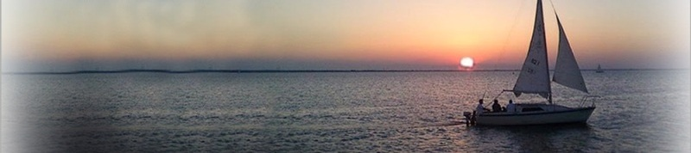

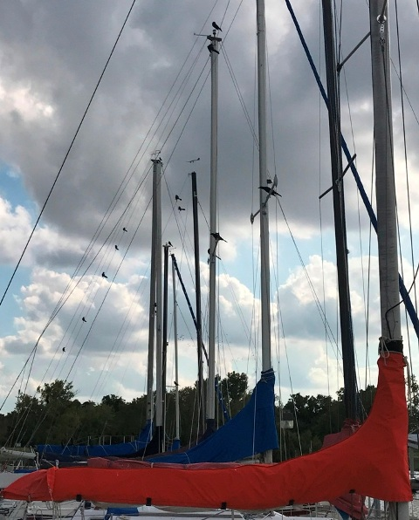
Birds, birds, birds…
Lake Hefner seems to be quite literally, going to the birds! I have never seen so many. Our little sailing pond seems to be the favorite layover for every type of migratory bird, duck, geese, and foul. Don’t get me wrong and please don’t call the local Audubon Chapter. When they fill the skies it is a magnificent thing to see, and let’s face it, without birds, the world would be over-run with insects in a matter of weeks. I just don’t understand why they seem to congregate at marinas. They are such messy little creatures, and it goes without saying, that the larger the bird, the larger the mess. The big geese are the worst, Am I right? I use my boat(s) two and three times a week, and wash the decks almost as much, but it seems the cleaner the boat, the more they want to target it. Yesterday I had to clean up a huge mess in the cockpit of the Capri. It took thirty minutes! The suspect bird must have been huge, lazy, and suffering with some form of lower digestive tract issues. Ugh! We’re talking dried on black and white ooze complete with scales and fish heads. Sorry to be so graphic. I have heard that putting out rubber snakes might scare off the birds, I’m doubtful.

S/V Nevorica
Chapter Nine (continued from the September newsletter)
The Bahamas… the summer of 1991

After two days of sailing and a brief layover at Great Stirrup Cay we sailed into Nassau, the capital city of the Bahamas. Nassau is home to weather beaten, 18th-century forts; elegant, Victorian mansions, noble architecture; and international goods, from hand painted conch shells to Rolex watches. It seems to have an abundance of everything. Resort hotels, casinos, cabaret shows, cruise ships and thousands of people. Always ready to capitalize on a bargain, we found a Texaco fuel dock that appeared to be part of an abandoned marina. Securely tied and protected from the weather in Nassau Harbor, we relaxed for a few days, had seafood dinners, and did some modest gaming at the casino on Paradise Island.
At 0653 on November 17, we cast our moorings from the dock and headed for the open water. My plan was to go around the east side of Eleuthera Island and make our next landfall at Little San Salvador, a trip of about 125 NM (nautical miles). By 0800 the next morning we were somewhere way off the east coast of said island, positionally challenged (lost at sea). Remember this was 1991, and GPS navigation was being used mostly by the military and not yet available to the everyday sailor. Somewhere in the middle of the night my loran stopped picking up the signal and I was forced to begin using “DR”. DR means “dead reckoning” and has been used ever sense the first fool went sailing out of sight of land. It’s a simple calculation of speed multiplied by time equals distance, right? OK, Mix into that calculation Set (the effect of wind pushing you off course), Drift (the effect of water currents in the ocean, now recalculate for compass error, because a compass doesn’t really point to true north. Beginning to get the picture? Why do think the east half of the Caribbean was named the “West Indies”? Columbus was lost!
What this navigator failed to realize was, that as I sailed around the east coast of Eleuthera the strong current off the Bahama banks was pushing us further and further off shore into the Atlantic. By daybreak all we could see in any direction was a featureless horizon of blue ocean. Great!
True, we were lost, but far from desperate. We had a compass, a sound vessel, plenty of food, and lots of water. For the remainder of the morning we sailed in a southwesterly direction toward what I was pretty sure was our island. By noon, there was no land in sight, but as luck would have it, we spotted a passing freighter, and raised them on the radio. It went something like this:
“Hailing unknown freighter, this is Nevorica, come in please.” Hailing unknown freighter, this is Nevorica, come in please.” (repeated three times). A voice responded, “Go ahead, Nevorica”.
My reply, “ah yes Sir, my crew and I were wondering if you would be so kind as to tell us where we are…”. After some delay the nice voice came back with the coordinates of our location. I assume the delay was to allow the crew on the bridge of the freighter to stop laughing.
It turned out that my skills with DR navigation had put us nearly 100 miles out into the Atlantic Ocean. Oh well, fortunately we’re not in a rush to get there anyway. I plotted our position on the chart and set a new course. By that evening we dropped anchor off the uninhabited beach of pretty Little San Salvador Island. A nice trip of 170 NM.

We stayed for two days and decided that our next stop south would be Cat Island, a trip of about 35 miles. It was a rough trip, and it was here the pounding seas were beginning to find Nevorica’s weaknesses. Beating into head seas, we had trouble holding our heading toward Cat Island. The real problem was the rigging and it was becoming serious. The Samson post, a beam in the bow that supports the bow spirit was giving way. If we lost the bow spirit in this blow, we would lose the entire rig. The mast, sails, rigging, everything would literally come down. The only thing we could do was to plan repairs on Cat Island.
We left early enough that morning, but the foul weather put us coming in late at Fernandez Bay, Cat Island. It is highly recommended by the best navigators in this region to make landfall on any island by early afternoon, and I swear, I tried. It was well past dark on my arrival as we began to feel our way into the shore. It was a black dark night, there were no markers, so I approached at a crawl, still not sure of my position. I made a desperate call on the radio to see if anyone was awake. I was surprised and pleased to hear an answer: “ya mon, you fine, keep comin’” As we got closer, we began to make out small specks of light on the beach. The locals that operated the beachside resort had put tiki torches up and down the beach to help guide us in. Now that is Island hospitality.
The next morning we rowed the dinghy ashore anxious to meet our new friends. The resort at Fernandez Bay was unique and the people that ran it were friendly to visiting yachts, but then of course, we had credit cards, and there were only two boats in the small bay. The lodge was built near the beach and made of stone and log beams. It was shaded by palm and hibiscus and open in all directions which allowed the cool sea breeze to pass through unabated. A large rock patio faced the bay and at its center was a circular fire pit. This was also the center of the evening meal custom prepared from local fish and lobster. I’m pretty sure it was the first and only time I have ever seen a do-it-yourself “honor bar”, complete with rums, vodkas, ice, and mixers. We stayed for almost a week exploring the island on bicycles and exploring the beaches with the dinghy.
With limited tools and resources, I tried to repair some of the rig damage that had become all to apparent from the rough trip down island. I layered on a heavy fiberglass patch, but I admit, about all I could do was cosmetic. The engine was no better. It was becoming harder and harder to start, and when it ran it produced more smoke than it did power. Quietly I was beginning to doubt our ability to continue, and each time we put to sea, would be riskier than the one before. We were still hundreds of miles from the Caribbean, but I just could not bring myself to give up on the dream.
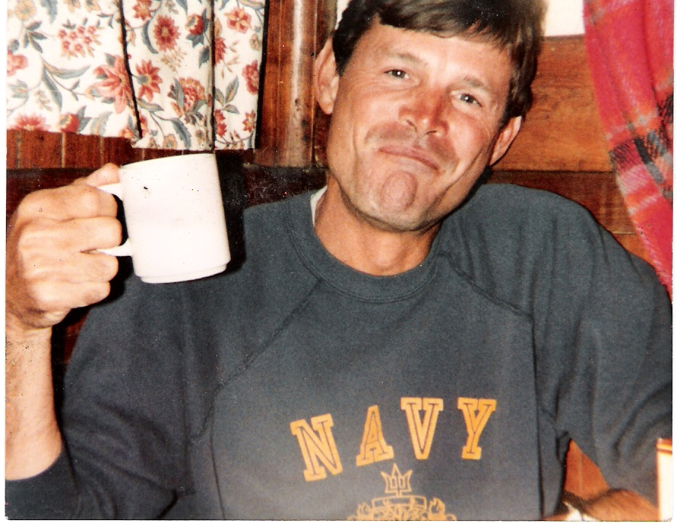
While trying to transit the rough seas from Cat Island to San Salvador, the diesel all but ceased to function and my port side chain plates were being pulled from the hull by the overstressed rigging. It was now becoming all together evident my little vessel was not up to it, and I was forced to consider the bleak option of turning back, or risking our lives by going forward. The dream of sailing the Caribbean would have to wait for another day, and so we came about and returned to our friends at Cat Island. After four days we set sail for Ft Lauderdale, and home.

The End

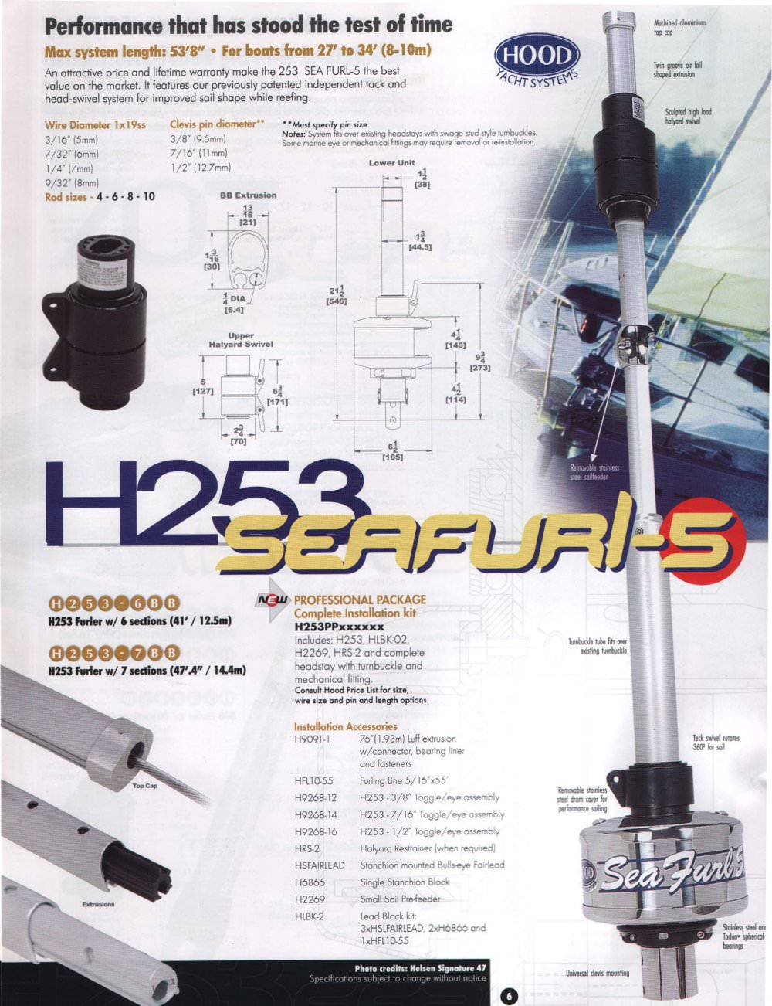
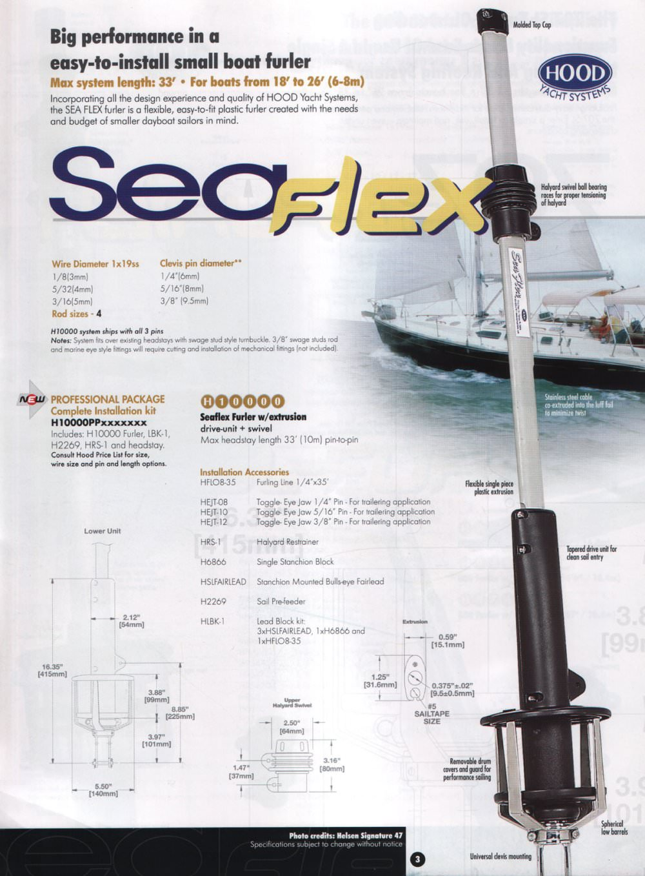
Jib furling systems…they make it so easy!
A must for the solo sailor! I am a dealer/installer for Hood Sea Flex and Sea Furl. Jib FurClers make sailing a lot easier for the solo sailor and much safer than having to run forward to raise and lower the jib sail. Pull the furling line and roll it up. It’s that easy!
SeaFlex for boats 18 to 26 feet
SeaFurl for boat 25 to 33 feet

Call for a quotation…

Boats for Sale
Year | Make/Model | Engine/OB | Sails | General Condition | Trailer | Asking
1983 | Catalina 25 | 9.9 Elect start Merc | Main & furling jib | Good | yes | $7,000
1975 | Chrysler 22 | 5 HP Nissan | main & jib | Fair | yes | $2,200
1971 | Irwin 23 | 9.9 Johnson | Main, 2 jibs | Good | yes | $2,700
1985 | Sovrign 23 | 9.9 Honda elect start | main, 2 jibs, spin | Very good | yes | $8,900
1974 | Ericson 27 | inboard gas A4 | main & jib | good | yes | $5,800
1978 | AMF Sunbird 16 | none | Main, jib | Very good | yes | $2,800
1992 | Catalina Capri 16 | none | Main, furl jib | Very good | yes | $3,400

No trees or paper were harmed in the transmission of this document, however millions of electrons with were horribly inconvenienced.



